

# **Department of Basic Science and Humanities**

# **Institute of Engineering & Management, Kolkata**

**“Tic-Tac-Toe Game”**

**Submitted by:**

**Name: Srinjoy Paul**

**Enrolment Number: 12022002002191**

**Stream: Computer Science & Engineering**

**Section: A**

**Class Roll no.: 82**

**Subject: Programming for Problem Solving**

**Subject Code: ESC-103(Pr)**

**Under the supervision of-**

**Prof. Swarnendu Ghosh**

**Academic Year: 2022-2026**

**(**PROJECT REPORT SUBMITTED IN FULFILMENT OF THE REQUIREMENTS FOR THE SECOND SEMESTER)



**CERTIFICATE OF RECOMMENDATION**

We hereby recommend that the project prepared under our supervision by **Srinjoy Paul**, entitled “**Tic-Tac-Toe Game**” be accepted in fulfilment of the requirements for the degree of fulfilment of the second semester.

___________________ ____________________

Head of the Department Project Supervisor

1. **Introduction:**

This project is assigned to me for developing a **Tic-Tac-Toe Game** with the help of basic C programming language. The basic aim of the project is to create a Tic-Tac-Toe Game where we can create play with the help of c programming.

1. **Variable Description:**

* Int row:

To calculate and store the value in specific row.

* Int column:

To calculate and store the value in specific column.

* Int count:

To calculate the count.

* Int **gameResult**:

To store the game result.

* **Char playerSign**:

To store sign for the player.

* **Int playCount**:

To store play count of the game.

* Int cell:

To store the values in the cell.

1. **Function Description:**

* **initializeBoard():**

To **initialize the game board**

* **showBoard():**

To **show the game board**.

* **updateBoard():**

To **update the game board**.

* **checkWinner():**

To **check the winner of the game**.

1. **Programs:**

**#include <stdio.h>**

**// Globally declared 2D-array**

**char board[3][3];**

**// Function to initialize the game board**

**void initializeBoard()**

**{**

**for (int i = 0; i < 3; i++)**

**{**

**for (int j = 0; j < 3; j++)**

**{**

**board[i][j] = ' ';**

**}**

**}**

**int count = 1;**

**printf("\n\n\t ");**

**for(int i = 0; i < 3; i++)**

**{**

**for(int j = 0; j < 3; j++)**

**{**

**printf("%d", count++);**

**if (j < 2)**

**{**

**printf(" | ");**

**}**

**}**

**if (i < 2)**

**printf("\n\t----------------\n\t ");**

**}**

**printf("\n\n\n");**

**}**

**// Function shows the game board**

**void showBoard(int x, int y)**

**{**

**printf("\n\n\t ");**

**for (int i = 0; i < 3; i++)**

**{**

**for (int j = 0; j < 3; j++)**

**{**

**printf("%c", board[i][j]);**

**if (j < 2)**

**{**

**printf(" | ");**

**}**

**}**

**if (i < 2)**

**printf("\n\t----------------\n\t ");**

**}**

**printf("\n\n\n");**

**}**

**// Function to update the game board**

**int updateBoard(int cell, char playerSign)**

**{**

**int row = (cell - 1) / 3;**

**int col = (cell - 1) % 3;**

**int isValid = 1;**

**// accessing already played cell number**

**if (board[row][col] != ' ')**

**{**

**printf("\nInvalid: Cell is already Filled!\n");**

**isValid = 0;**

**}**

**// valid cell position**

**else**

**{**

**board[row][col] = playerSign;**

**}**

**showBoard(row, col);**

**return isValid;**

**}**

**// Function to check the winner of the game**

**int checkWinner(char sg)**

**{**

**// check all rows**

**if (board[0][0] == sg && board[0][1] == sg && board[0][2] == sg ||**

**board[1][0] == sg && board[1][1] == sg && board[1][2] == sg ||**

**board[2][0] == sg && board[2][1] == sg && board[2][2] == sg)**

**{**

**return 1;**

**}**

**// check all columns**

**else if (board[0][0] == sg && board[1][0] == sg && board[2][0] == sg ||**

**board[0][1] == sg && board[1][1] == sg && board[2][1] == sg ||**

**board[0][2] == sg && board[1][2] == sg && board[2][2] == sg)**

**{**

**return 1;**

**}**

**// check both diagonals**

**else if (board[0][0] == sg && board[1][1] == sg && board[2][2] == sg ||**

**board[0][2] == sg && board[1][1] == sg && board[2][0] == sg)**

**{**

**return 1;**

**}**

**// There is no winner**

**return 0;**

**}**

**// Start your game from here**

**void playTicTacToe()**

**{**

**int gameResult = 0;**

**int cell = 0;**

**int playCount = 0;**

**int updationResult = 1;**

**char playerSign = ' ';**

**// start playing the game**

**while (!gameResult && playCount < 9)**

**{**

**if (playCount % 2 == 0)**

**{**

**// player 1**

**printf("\nPlayer 1 [ X ] : ");**

**playerSign = 'X';**

**}**

**else**

**{**

**// player 2**

**printf("\nPlayer 2 [ O ] : ");**

**playerSign = 'O';**

**}**

**scanf("%d", &cell);**

**if (cell > 0 && cell < 10)**

**{**

**updationResult = updateBoard(cell, playerSign);**

**// if updation is possible**

**if (updationResult)**

**{**

**gameResult = checkWinner(playerSign);**

**// print the winner of the game**

**if (gameResult)**

**{**

**printf("\t *** Player %d Won!! ***\n", playerSign == 'X' ? 1 : 2);**

**}**

**playCount++;**

**}**

**}**

**else if (cell == -1)**

**{**

**printf("\n\tGame Terminated\n");**

**return;**

**}**

**else**

**{**

**printf("\nPlease Enter a valid cell value\n");**

**}**

**}**

**// no one won the game**

**if (!gameResult && playCount == 9)**

**{**

**printf("\n\t *** Draw... ***\n");**

**}**

**printf("\n\t --- Game Over --- \n");**

**}**

**int main()**

**{**

**printf("--------- Tic Tac Toe ----------\n\n");**

**printf("\n* Instructions \n\n");**

**printf("\tPlayer 1 sign = X\n");**

**printf("\tPlayer 2 sign = O");**

**printf("\n\tTo exit from game, Enter -1\n");**

**printf("\n\n* Cell Numbers on Board\n");**

**initializeBoard();**

**char start = ' ';**

**printf("\n> Press Enter to start...");**

**scanf("%c", &start);**

**if (start)**

**{**

**int userChoice = 1;**

**// restart the game**

**while (userChoice)**

**{**

**playTicTacToe();**

**printf("\n* Menu\n");**

**printf("\nPress 1 to Restart");**

**printf("\nPress 0 for Exit");**

**printf("\n\nChoice: ");**

**scanf("%d", &userChoice);**

**if (userChoice)**

**{**

**initializeBoard();**

**}**

**printf("\n");**

**}**

**}**

**printf("\n :: Thanks for playing Tic Tac Toe game! :: \n");**

**return 0;**

**}**

1. **Output:**

**Sample outputs(screenshots) to demonstrate the functionality of the program.**

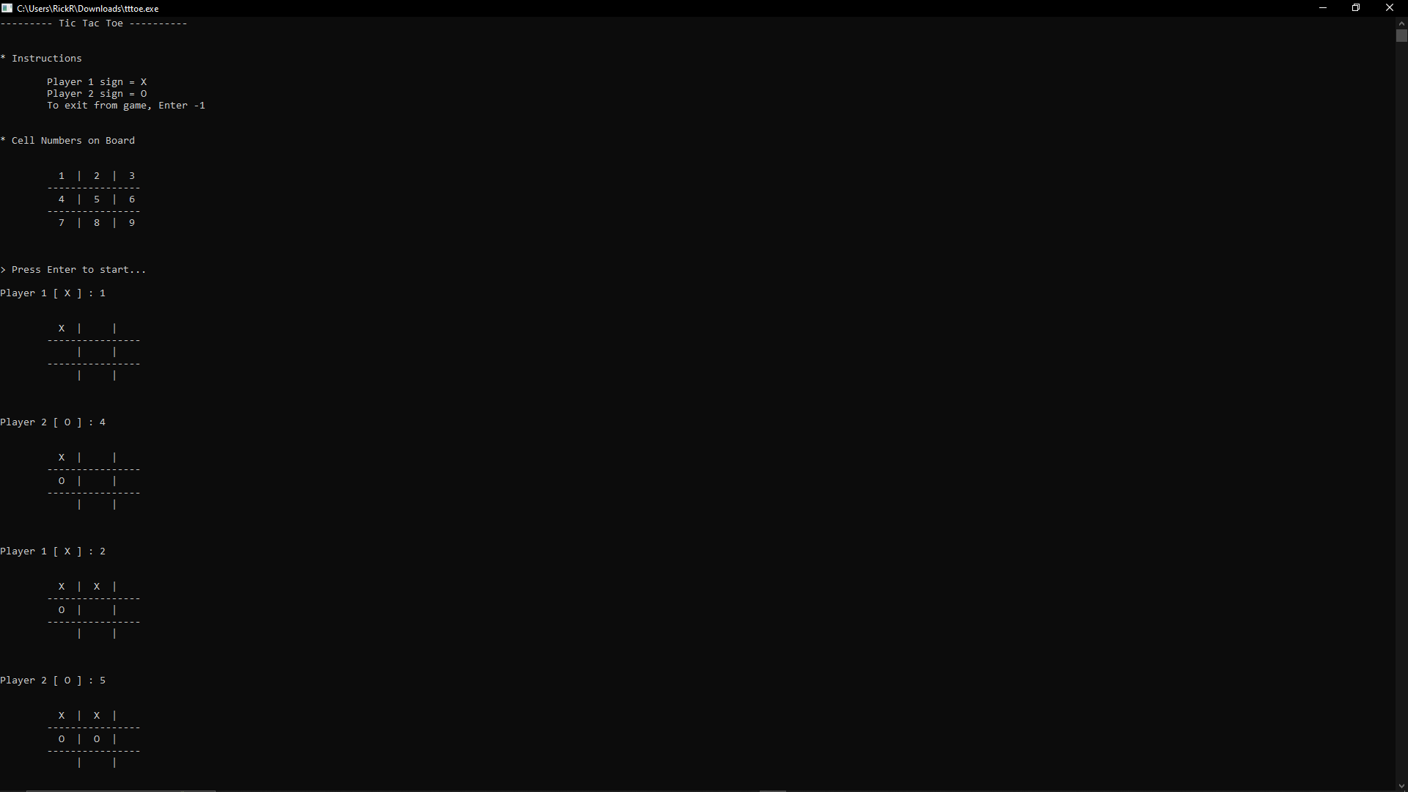

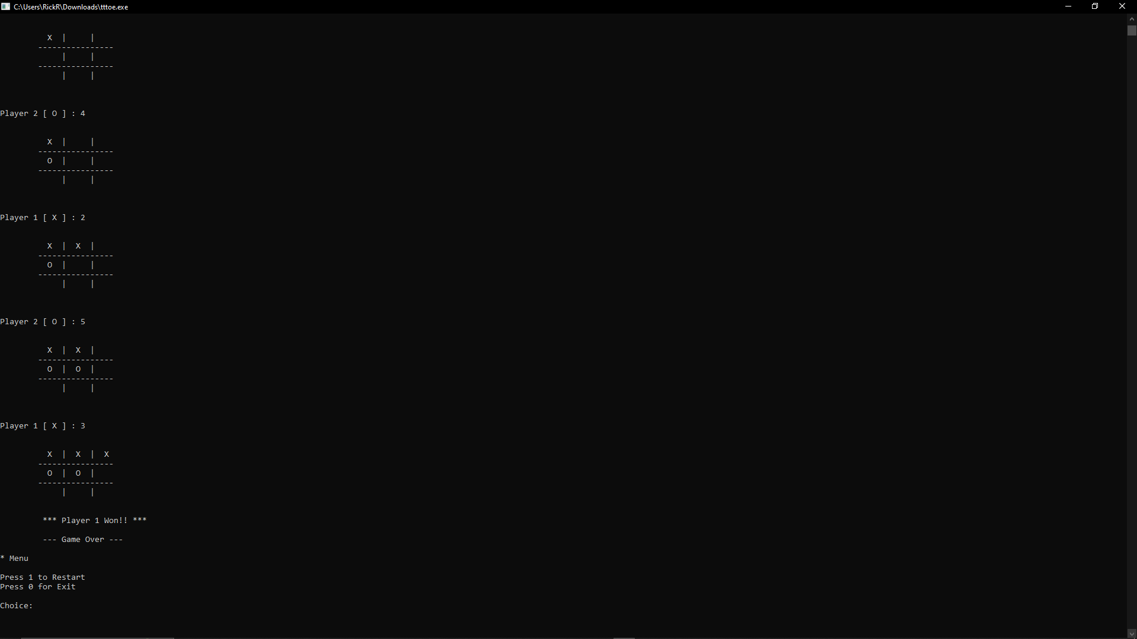

**Conclusion:**

**It is a Tic-Tac-Toe game made with pure C language. After running the executable file it’ll open a command line interface where the one can play tic-tac-toe.**